Linux Basic Commands Assignment
Step 1: Creating and Renaming Files
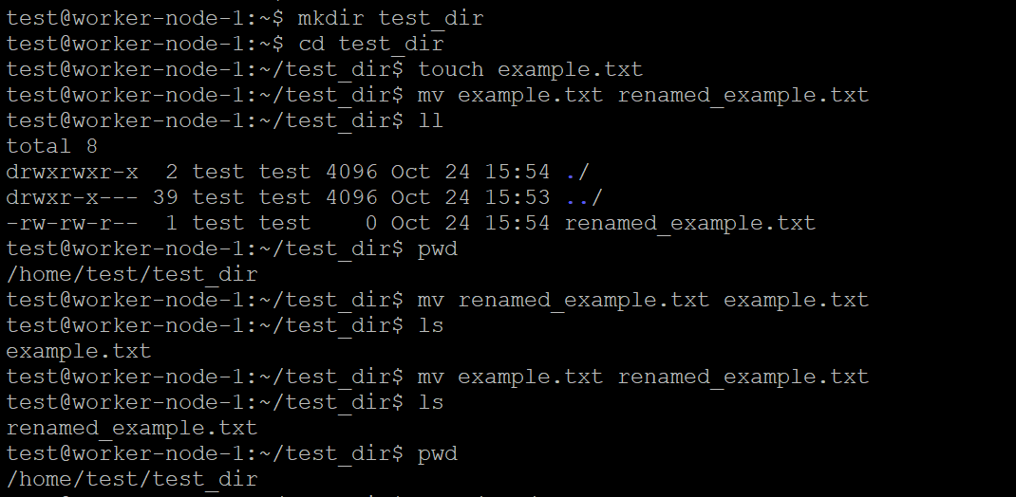
Step 2. Viewing File Contents
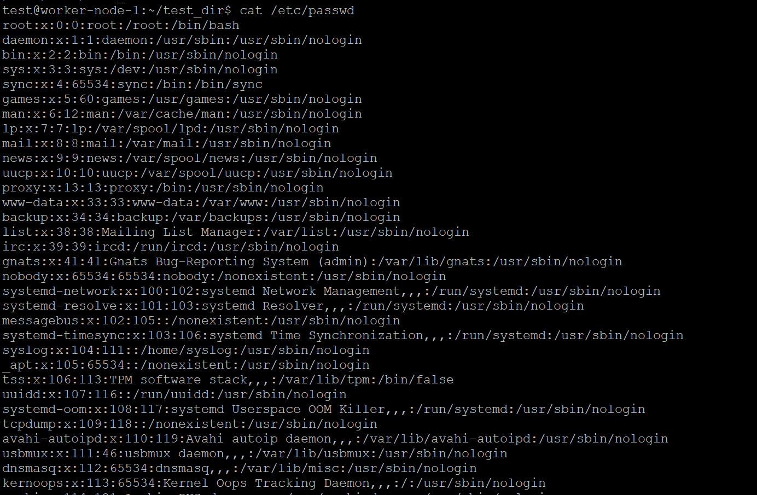
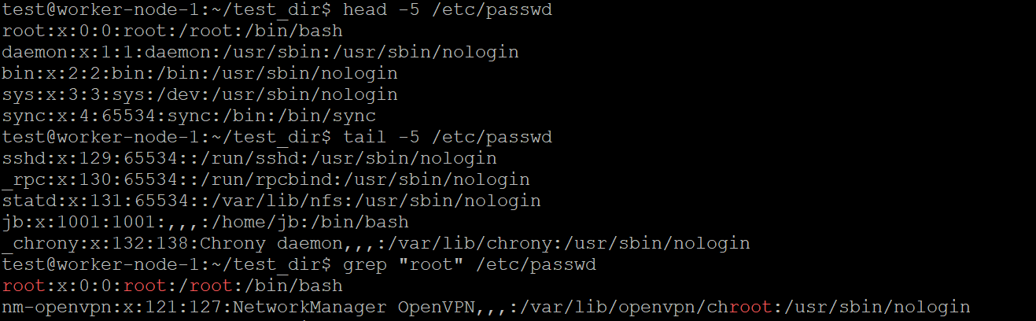
Step 3.Searching for Patterns
Step 4. Zipping and Unzipping
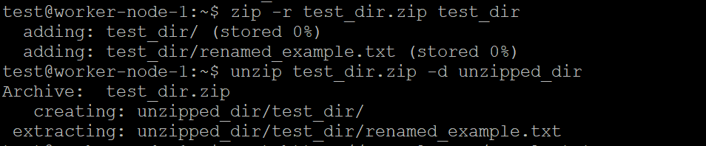
Step 5. Downloading Files
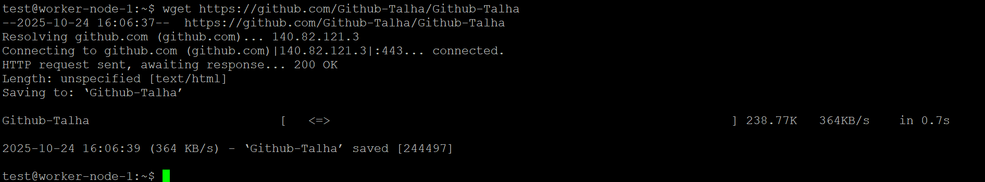
Step 6. Changing Permissions
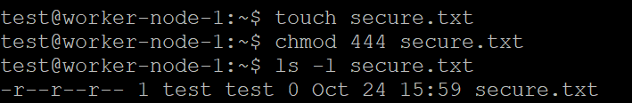
Step 7. Working with Environment Variables
